TWN

Third World Network

Email: twnet@po.jaring.my
Website: www.twnside.org.sg
Address: 131 Jalan Macalister, 10400 Penang, MALAYSIA
Tel: 60-4-2266728/2266159 Fax: 60-4-2264505

Briefing Paper
2

UN Climate Change Talks - 8th session of the AWG-KP and 6th session of the AWG-LCA

1 June-12 June 2009, Bonn

Climate Debt: A Primer

A wealthy minority of the world’s countries and corporations are the principal cause of climate change; its adverse effects fall first and foremost on the majority that is poor. This basic and undeniable truth forms the foundation of the global climate justice movement.

Climate change threatens the balance of life on Earth and with it human communities everywhere. Addressing climate change requires urgent actions by all peoples, rich and poor, and all countries, developed and developing.

But to be effective the response to climate change must also be fair. Developing countries and communities are unlikely to ignore the wealthy’s historical responsibility for the causes and consequences of climate change. Nor are they likely to sit by while a wealthy minority continues to consume an excessive proportion of the Earth’s limited environmental space. Nor should they.

Responsibilities of the rich

Atmospheric concentrations of greenhouse gases are higher today than anytime in millennia. Emitted since the industrial revolution, they have built up in the atmosphere, blanketing the Earth and causing considerable warming. Responsibility for these emissions lies principally with the developed countries. With less than one fifth of the world’s population they have grown wealthy while emitting almost three quarters of all historic GHG emissions into an atmosphere they share with all life on Earth.

Problems of the poor

The excessive emissions of the wealthy have destabilized the climate, harming the poor and threatening our future. Already, climate change is causing the oceans to rise and acidify; melting ice caps, glaciers and permafrost; damaging forests, coral reefs and other ecosystems; and intensifying fires, floods, droughts and other extreme weather events. It is increasing water stress, hindering the production of food, altering disease vectors and threatening the infrastructure and resources that are the life-blood of millions of people. Poor countries and communities that have done least to cause climate change suffer first and worst from its adverse effects.

The concept of climate debt

For their disproportionate contribution to the causes of climate change and its adverse effects, developed countries owe a two-fold climate debt.

- For over-using and substantially diminishing the Earth’s capacity to absorb greenhouse gases – denying it to the developing countries that most need it in the course of their development – the developed countries have run up an “emissions debt” to developing countries.
- For the adverse effects of these excessive emissions – contributing to the escalating losses, damages and lost development opportunities facing developing countries – the developed countries have run up an “adaptation debt” to developing countries.

The sum of these debts – emissions debt and adaptation debt – constitutes the “climate debt” of developed countries.

Emissions debt

The extent of developed countries’ emission debt reflects their excessive past, present and proposed future use of shared environmental space. With less than 20% of the population, developed countries have produced more than 70% of historical emissions since 1850 (Figure 1), far more than their fair share based on equal per-person emissions (Figure 2).

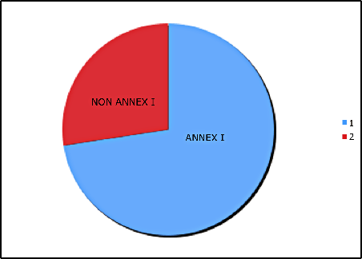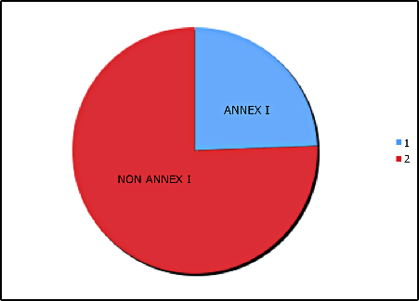
Figure 1: Actual historical emissions
Figure 2: Equal individual shares (past)

After diminishing the Earth’s environmental space – denying it to poor countries and communities – the same rich countries now propose consuming a disproportionate share of the remaining space through until 2050 (Figure 3) when compared to an equal per-capita share (Figure 4).

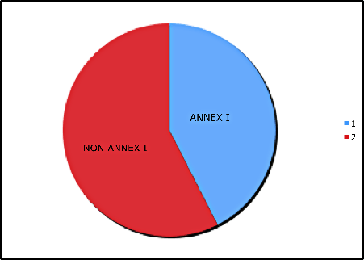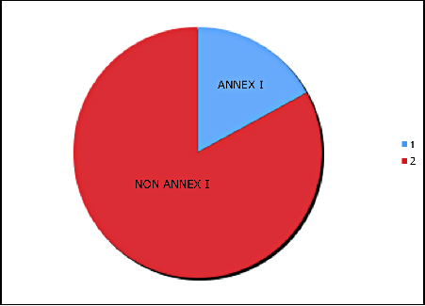
Figure 4: Equal individual shares (future)
Figure 3: Proposed future emissions

Developed countries representing a minority of people have appropriated the major part of a shared global resource for their own use – a resource that belongs to all and should be fairly shared with the majority of people.

By basing their future “assigned amounts” of emissions on their past excessive levels, they are effectively proposing to write-off the full amount of their historical emissions debt (figures 1 and 2), and to simultaneously appropriate trillions of dollars of remaining atmospheric space which should rightfully be allocated to the South (figures 3 and 4).

Their proposals, if adopted, would lock developing countries into low and rapidly decreasing per-capita shares, denying them the environmental space needed to build the houses, schools, roads and infrastructure that developed world already has. Their proposals would deepen the debt of developed countries rather than honoring it, leveraging past injustices into a future climate regime, and proposing a system in which the “polluter profits” and the “poor pays” for the excessive historical and current consumption of the rich countries.

Adaptation debt

As well as freeing up environmental space, developed countries must accept responsibility for the adverse effects of their historical and continuing high per-person emissions on poor communities and countries. Among the hardest hit are:

- Farmers and farming communities. In some countries rain-fed agriculture is expected to drop by up to 50% by 2020, leaving millions of people without food.
- Indigenous and local communities. Indigenous peoples and local communities are harmed by changing ecosystems and threats to traditional livelihoods.
- Women. 70% of the world’s poor are women. Women provide half of the world’s food. They are hardest hit by climate change and must be at the center of any solution.
- Poor communities. At particular risk are people concentrated in high-risk areas, such as coastal and river flood plains, or areas prone to extreme weather events.
- People relying on scarce water resources. Between 75 and 250 million of people are likely to face increased water stress by 2020 due to climate change.
- Communities susceptible to health impacts. The health of millions of people will likely be affected through increased malnutrition, increased disease burden and death and injury due to extreme weather events.

These impacts are caused by the historical emissions that have led to current levels of warming, and that will lead to considerable future “committed” warming as the Earth’s oceans and other systems warm. The very existence of some communities is threatened while others face serious impediments to their efforts to lift billions of people out of poverty and to promote development.

There is no way to predict the full extent of future adverse impacts and costs – emission pathways are uncertain and the climate system is too complex. However, any just approach to climate change must ensure that those who have benefited in the course of causing climate change compensate the victims of climate change. They should cover the full costs of avoiding adverse impacts and provide compensation for those harms that cannot be avoided. This constitutes the adaptation debt of the rich industrialized world to poor countries, communities and people.

Climate debt as a component of ecological debt

Climate debt is a component of a larger ecological debt, reflecting the excessive pollution and over-use by the wealthy of the goods and services provided by nature (see figure 5). Over-consumption of food, water, minerals, forests, fisheries and other goods by a minority is contributing to excessive use of scarce resources. The United States’ ecological footprint per person (measured as the productive land and sea required to provide resources and to absorb wastes) is more than four times the globally sustainable level, more than four times China’s and more than nine times India’s.

Globally, our ecological footprint exceeds the Earth’s capacity to regenerate by about 30%. If present trends continue, by mid-2030s we will require the equivalent of two planets. Of this, our carbon footprint forms a large and growing part. As a consequence, any effort to advance the cause of climate justice must be rooted in a broader effort to promote ecological and social justice between rich and poor, developed and developing countries.

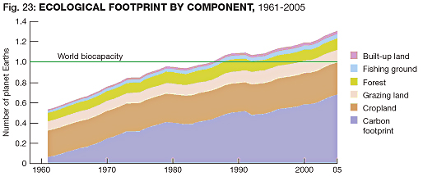
Figure 5
(Source: WWF Living Planet Report)
Repaying climate debt

The wealthy industrialized world must take responsibility for repaying the full measure of their climate debt. Doing so is not merely right; it also provides the basis of an effective climate solution. A fair and effective climate solution requires at a minimum that:

- Developed countries repay the full measure of their adaptation debt to the developing countries and communities who did little to cause climate change and are its first victims. They must provide financing and technology to ensure full compensation for losses suffered, and the means to avoid or minimize future impacts where possible. They should commit to fully repay their adaptation debt to developing countries, commencing immediately.
- Developed countries must repay the full measure of their emission debt to developing countries and communities. There will be no sustainable climate solution if developed countries seek to continue polluting at 70% or more of their 1990 levels all the way through until 2020 (consistent with 30% cuts). To avoid deepening their debt, developed countries must seek to become carbon neutral and more. Reflecting their historical responsibility, their assigned amounts of atmospheric space in any future year should be even lower. They must take a lead in cutting emissions through deep domestic reductions, and by accepting assigned amounts that reflect the full extent of their historical emissions debt.
- Developed countries must provide the financing and technology required by developing countries to live under the twin constraints of a more hostile climate and restricted atmospheric space. They must honor their obligation to provide the full incremental costs of emission reductions undertaken in developing countries, so that these countries can play their part in curbing climate change, while still meeting the needs and aspirations of their people.
_______________________________________________________________________

Selected recent statements on climate debt

DECLARATION BY HEADS OF STATE OF BOLIVIA, CUBA, DOMINICA, HONDURAS, NICARAGUA AND VENEZUELA (CUMANA DECLARATION)

As for climate change, developed countries are in an environmental debt to the world because they are responsible for 70% of historical carbon emissions into the atmosphere since 1750. Developed countries should pay off their debt to humankind and the planet; they should provide significant resources to a fund so that developing countries can embark upon a growth model which does not repeat the serious impacts of the capitalist industrialization.

SPEECH BY SRI LANKAN ENVIRONMENT MINISTER

The proposed emission cut (Bali Road Map) is not enough to save humanity. There should be objective criteria to save our planet. According to IPCC’s Carbon Budget, the environmental permissible carbon quota per person for 2009 is 2170 kg. In Sri Lanka each person emits 660 kg annually. In USA and Canada it is 22,000 kg per person, that is more that ten times the permissible quota. The world average is 4700 kg, that is twice the permissible level. That means low emitting countries like us could not emit more because our space has already been exploited by developed or global polluting countries without our consent. And more importantly they exploited future generations’ quota as well. If we adopt scientific criteria of IPCC these so called developed countries should cut their emission level by at least 70-90 % by 2020. On the other hand they owe environmental debt to other countries and should compensate them by establishing an adaptation fund. Now these countries adopt delaying tactics by setting out long goals (promising a 50% emission cut by 2050) which are to be honored by their children and blaming developing world for increasing emissions which are now well below the permissible level.

STATEMENT BY LESOTHO, CHAIR OF THE LDC GROUP, ON BEHALF OF LDCS AT JUNE 2009 BONN CLIMATE CHANGE TALKS

Developed countries should play a leadership role by undertaking ambitious nationally appropriate mitigation commitments. In these actions, the key underlying principle should be aspiring to minimize and avoid impacts to the vulnerable countries. Failure to combat climate change will increase poverty and hardship in our nations, and increase the debts owed to us for excessive emissions by the developed countries.

BOLIVIAN SUBMISSION TO UNFCCC

The climate debt of developed countries must be repaid, and this payment must begin with the outcomes to be agreed in Copenhagen. Developing countries are not seeking economic handouts to solve a problem we did not cause. What we call for is full payment of the debt owed to us by developed countries for threatening the integrity of the Earth’s climate system, for over-consuming a shared resource that belongs fairly and equally to all people, and for maintaining lifestyles that continue to threaten the lives and livelihoods of the poor majority of the planet’s population. This debt must be repaid by freeing up environmental space for developing countries and particular the poorest communities. There is no viable solution to climate change that is effective without being equitable. Deep emission reductions by developed countries are a necessary condition for stabilising the Earth’s climate. So too are profoundly larger transfers of technologies and financial resources than so far considered, if emissions are to be curbed in developing countries and they are also to realise their right to development and achieve their overriding priorities of poverty eradication and economic and social development. Any solution that does not ensure an equitable distribution of the Earth’s limited capacity to absorb greenhouse gases, as well as the costs of mitigating and adapting to climate change, is destined to fail.

STATEMENT BY PAN AFRICAN CLIMATE JUSTICE ALLIANCE (63 NGOS FROM ACROSS AFRICA)

By their excessive emissions, this wealthy minority has appropriated the majority of the Earth’s atmospheric space, which belongs equally to all and should be fairly shared. For their disproportionate contribution to the causes of climate change – denying developing countries their fair share of atmospheric space – the developed countries have run up an “emissions debt”. These excessive emissions, in turn, are the principal cause of the current adverse effects experienced by developing countries, particularly in Africa. For their disproportionate contribution to the effects of climate change – causing rising costs and damage in our countries that must now adapt to climate change – the developed countries have run up an “adaptation debt”. Together the sum of these debts – emissions debt and adaptation debt – constitutes the climate debt. Proposals by developed countries in the climate negotiations, on both mitigation and adaptation, are inadequate. They seek to pass on the costs of adaptation and mitigation, avoiding their responsibility to finance climate change response efforts in Africa. They also seek to write-off rather than reduce their emissions and continue their high per-capita emissions. This would deepen their debt and deny atmospheric space to the developing countries like ours, which would be asked to crowd into a small and shrinking remainder. We therefore call on developed countries to fully, effectively and immediately repay the climate debt they owe to African countries.

STATEMENT OF TRADE UNION CONFERENCE OF THE AMERICAS (LATIN AMERICA AND THE CARIBBEAN)

The case for climate justice is grounded in the recognition that the industrialized countries have a huge environmental debt toward the countries of the South on account of the development that, for more than 150 years, they have pursued on the basis of overexploiting fossil fuels: gas, carbon, and oil. The case in question is about a climate debt, which, therefore, they must pay off. Climate justice will only be reached when the Rich States of the North recognize this environmental debt, which also entails a drastic and urgent reduction of their contaminating emissions, the provision of funds for poor countries for climate change mitigation and adaptation processes, and the transfer of “clean” technologies to the global south for the development of environmentally sustainable productive processes.

ANCHORAGE DECLARATION AGREED BY INDIGENOUS REPRESENTATIVES FROM THE ARCTIC, NORTH AMERICA, ASIA, PACIFIC, LATIN AMERICA, AFRICA, CARIBBEAN AND RUSSIA

We call upon the Parties to the UNFCCC to recognize the importance of our Traditional Knowledge and practices shared by Indigenous Peoples in developing strategies to address climate change. To address climate change we also call on the UNFCCC to recognize the historical and ecological debt of the Annex 1 countries in contributing to greenhouse gas emissions. We call on these countries to pay this historical debt.

IPCC Fourth Assessment Report, Synthesis Report, page 72
The concept of a debt relating to climate change has been advanced by a growing number of Heads of State, Ministers, government officials, non-governmental organizations and social movements representing indigenous peoples, development, gender, organized labor, environmental and social justice groups in Africa, Asia, Latin America, Europe and North America.
This analysis focuses on emissions from fossil fuel use and assumes Annex I countries reduce by around 30% by 2020 (as proposed by the EU) and 85% by 2050, and that global emissions reduce by around 80% by 2050 (which still involves significant risk of exceeding 2°C and associated harm and costs).
Nicholas Stern, The Global Deal (2009) at page 154 (stating that the negotiation of emission rights “involve substantial financial allocations: at $40 per tonne CO2e a total world allocation of rights of, say, 30Gt (roughly the required flows in 2030) would be worth 1.2 trillion per annum”).
Under proposals by the European Union for a proposed reduction by Annex I countries of 30% from 1990 levels by 2050 and a 15-30% deviation by non-Annex I countries from so-called “business as usual” emissions, the United States would continue polluting at around 14 tonnes per-person in 2020 and India would be locked in at around 3 tonnes per-person. Transfers of technology and financing may alleviate some part of the burden of such an unjust allocation of environmental space by improving efficiency; but the burden of demonstrating this is possible should remain with the developed countries.
WWF Living Planet Report (2008) at page 14 onwards.
Nicholas Stern, The Global Deal (2009) at page 154 (stating “if the allocation of rights to emit in any given year took greater account both of history and of equity in stocks rather than in flows, then rich countries would have rights to emit which were lower than 2 tonnes per capita (possibly even negative)”.

